Input:

using System;

namespace Abdullah_CP_Lab_08

{

class Program

{

static void Main(string[] args)

{

string[] days = { "Mon", "Tues", "wed", "Thurs"};

for (int j = 0; j<days.Length;j++)

{

Console.WriteLine("days{0} is {1}",j,days[j]);

}

}

}

}

Output:

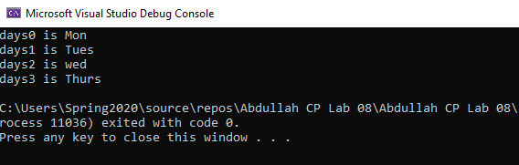

Input:

using System;

namespace Abdullah_CP_Lab_08

{

class Program

{

static void Main(string[] args)

{

Console.Write("Enter a positive integer");

int n = int.Parse(Console.ReadLine());

int[] array = new int[n];

Console.WriteLine("Enter the value of the array:");

for (int i =0;i<n;i++)

{

array[i] = int.Parse(Console.ReadLine());

}

bool symmetric = true;

for (int i = 0; i<array.Length/2;i++)

{

if (array[i]!= array[n-i-1])

{

symmetric = false;

break;

}

}

Console.WriteLine("Is symmetric? {0}", symmetric);

}

}

}

Output:

